Assignment 3
PNR: 260740150018
Name: PRATIK SUNIL ABHANG
Question:
Write a Python function to find the maximum of three numbers.
Program
def max_of_three(a=45, b=99, c=100):
return max(a, b, c)
print("Maximum using default values:", max_of_three())
a = int(input("Enter first number: "))
b = int(input("Enter second number: "))
c = int(input("Enter third number: "))
print("Maximum using user values:", max_of_three(a, b, c))

Input and Output
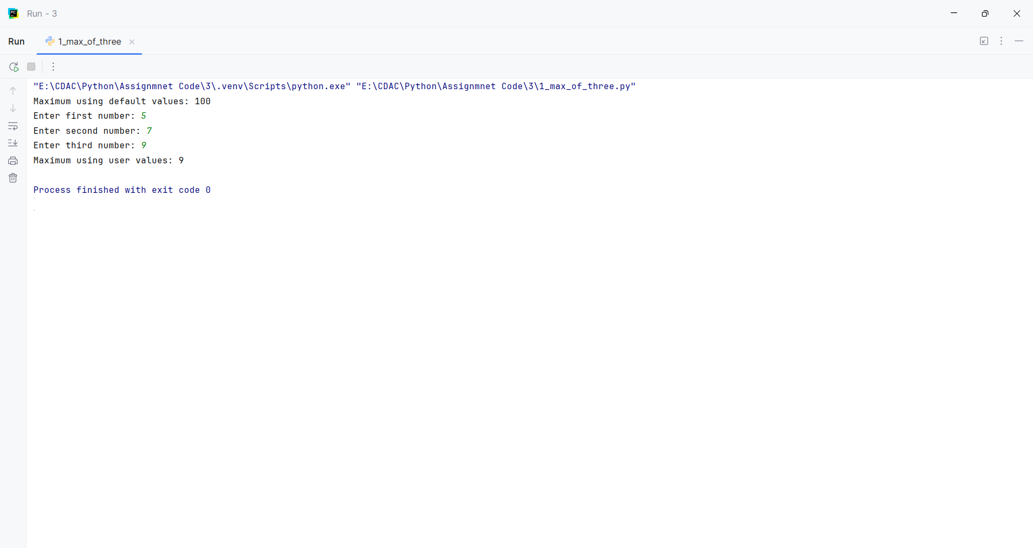
Question:
Create a function that takes a list of numbers and returns their sum.
Program
def sum_list(numbers):
return sum(numbers)
print(sum_list([1, 2, 3, 4, 5]))

Input and Output
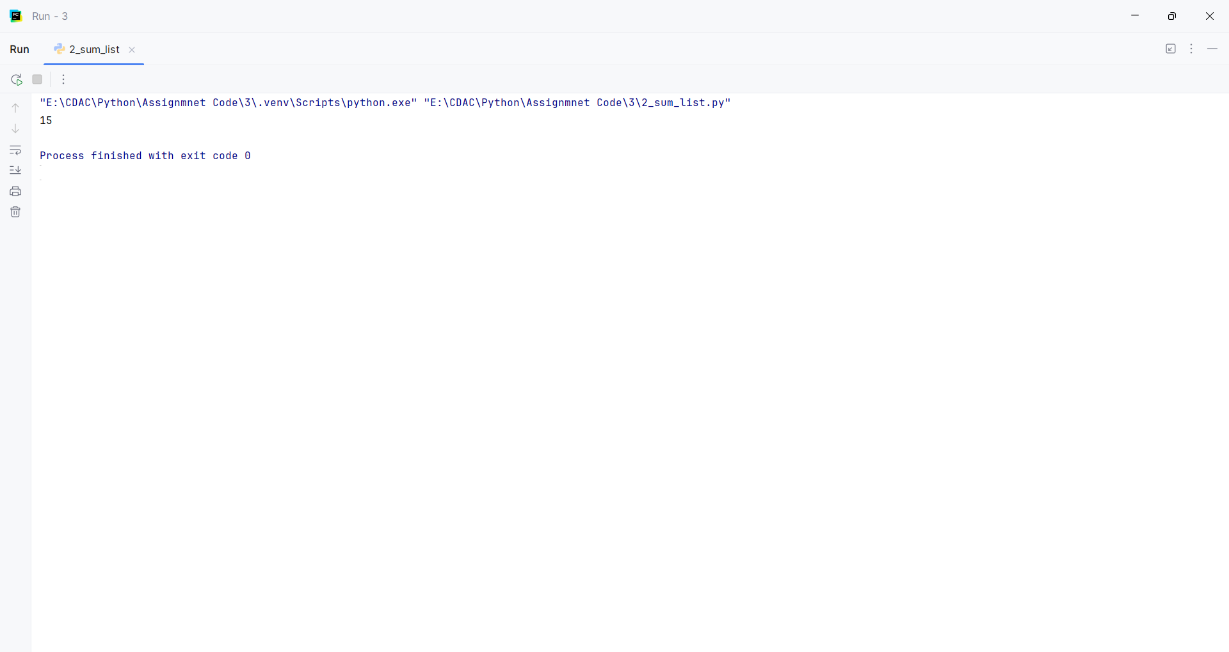
Question:
Write a function with a default argument that prints a greeting.
Program
def greet(name="World"):
print("Hello,", name)
greet()
name = input("Enter your name: ")
greet(name)

Input and Output
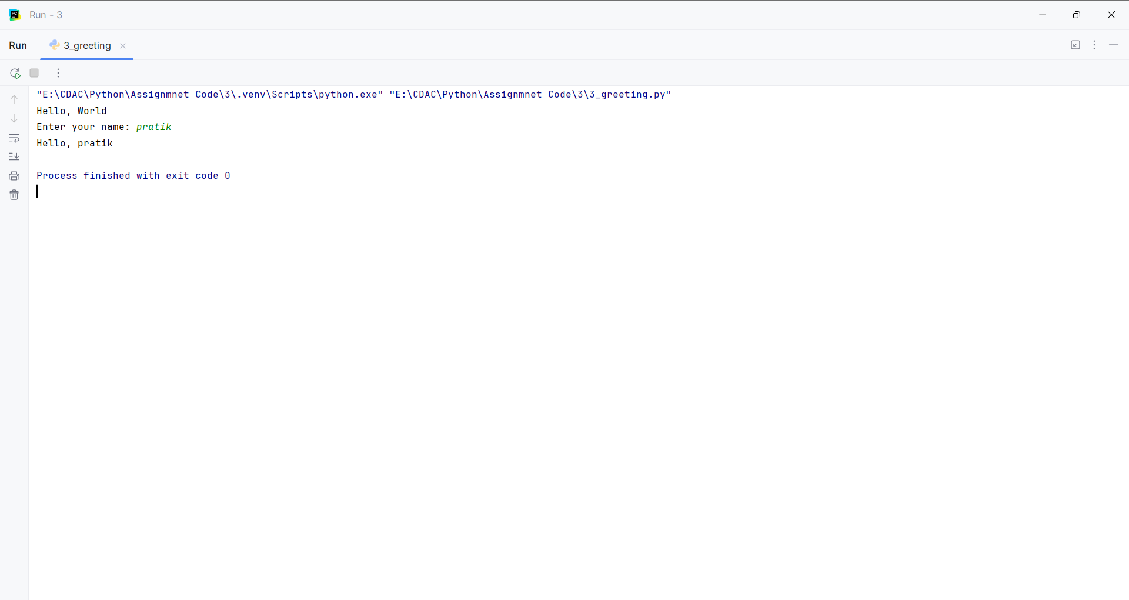
Question:
Write a function is_palindrome() that takes a string as an argument and returns True if the string is a palindrome (reads the same forward and backward) and False otherwise
Program
def is_palindrome(s):
return s == s[::-1]
text1 = "madam"
if is_palindrome(text1):
print(text1, "is Palindrome")
else:
print(text1, "is Not Palindrome")

Input and Output
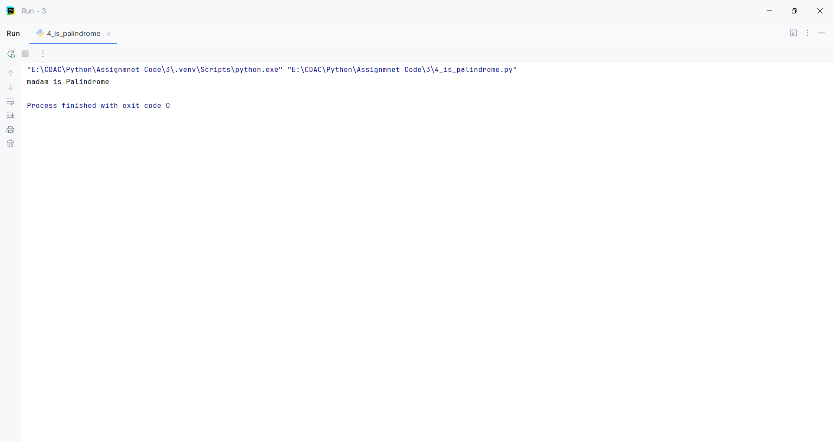
Question:
Write a function count_case() that accepts a string and returns a dictionary containing the count of uppercase and lowercase letters
Program
def count_case(s):
upper = 0
lower = 0
for ch in s:
if ch.isupper():
upper += 1
elif ch.islower():
lower += 1
else:
pass
print("Uppercase:", upper)
print("Lowercase:", lower)
text = input("Enter text: ")
count_case(text)

Input and Output
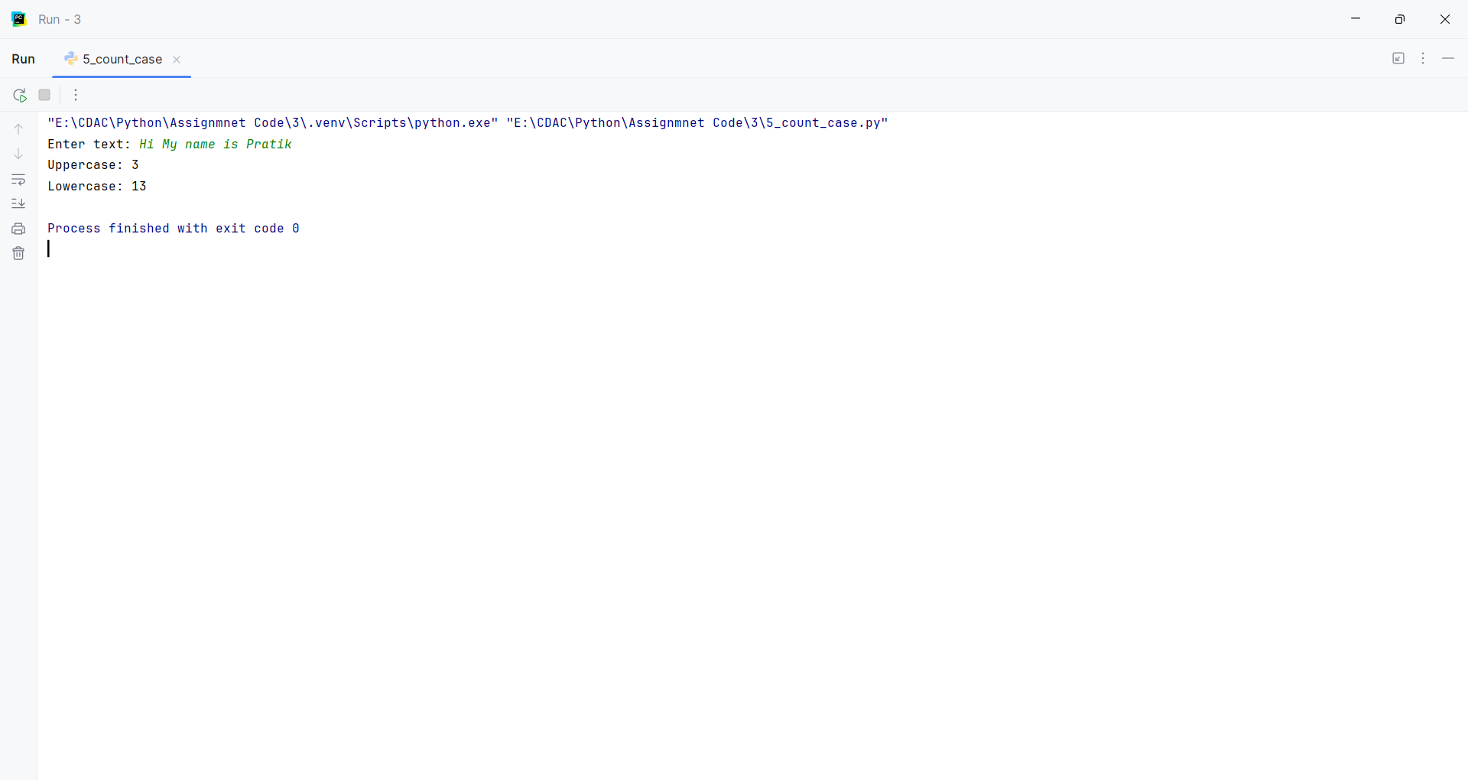
Question:
Write a function unique_list() that takes a list and returns a new list with distinct elements from the first list.
Program
def unique_list(lst):
return list(set(lst))
print(unique_list([1, 2, 2, 3, 3, 3, 4]))

Input and Output
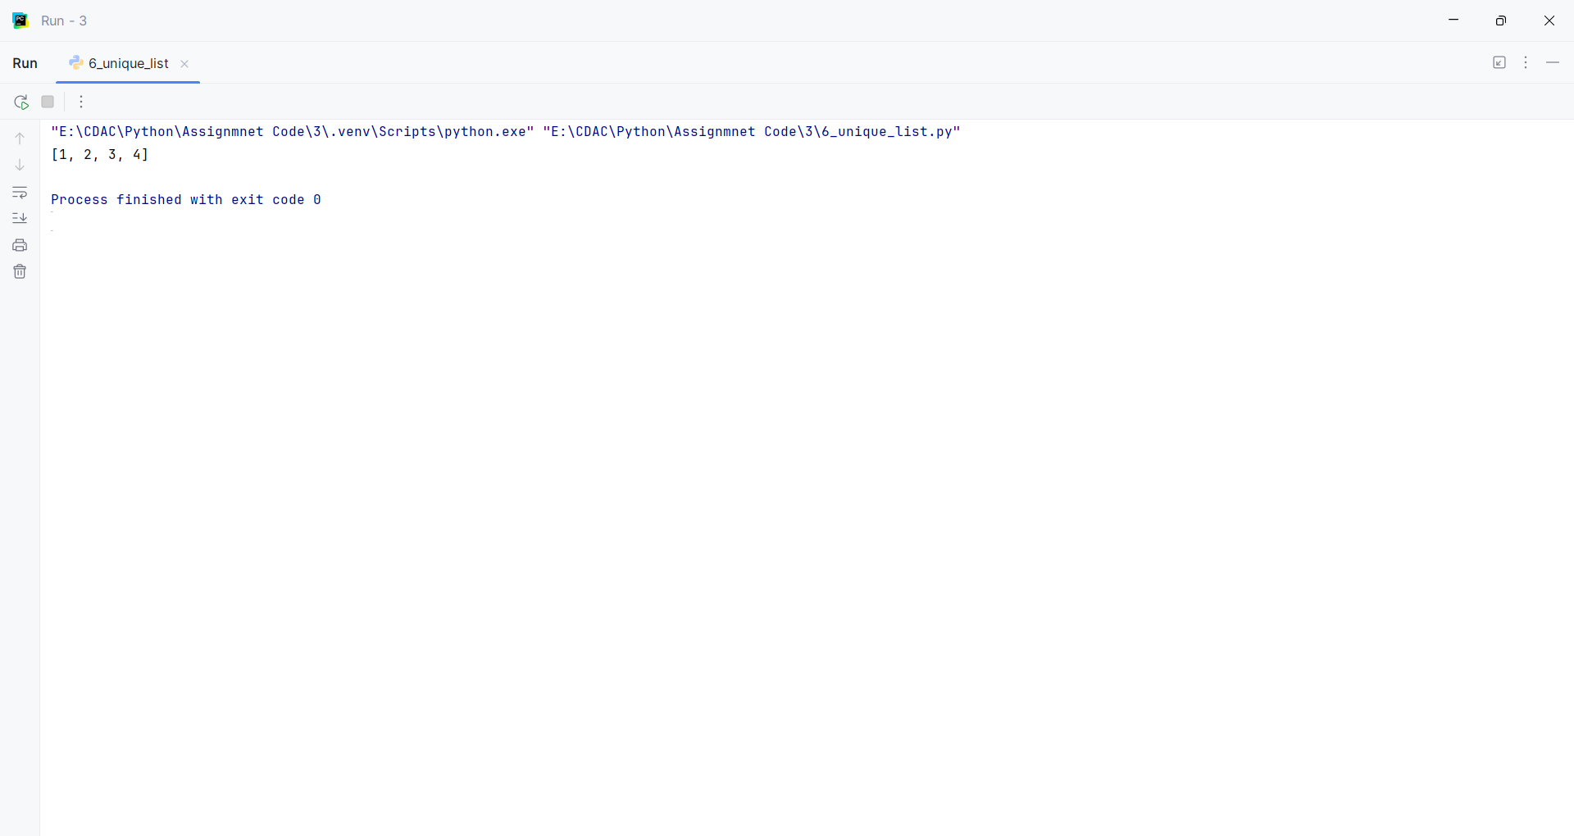

Assignment 4
PNR: 260740150018
Name: PRATIK SUNIL ABHANG

Question:
Given the string s = "Python Programming", write code to:
• Print the first character.
• Print the character at index 7.
• Print a slice from index 2 up to (but not including) index 8.
• Print a slice from the beginning up to index 5.
• Print a slice from index 6 to the end.
• Print the last character using negative indexing.

Program
def string_indexing():
s = "Python Programming"
print(s[0])
print(s[7])
print(s[2:8])
print(s[:5])
print(s[6:])
print(s[-1])
string_indexing()

Input and Output
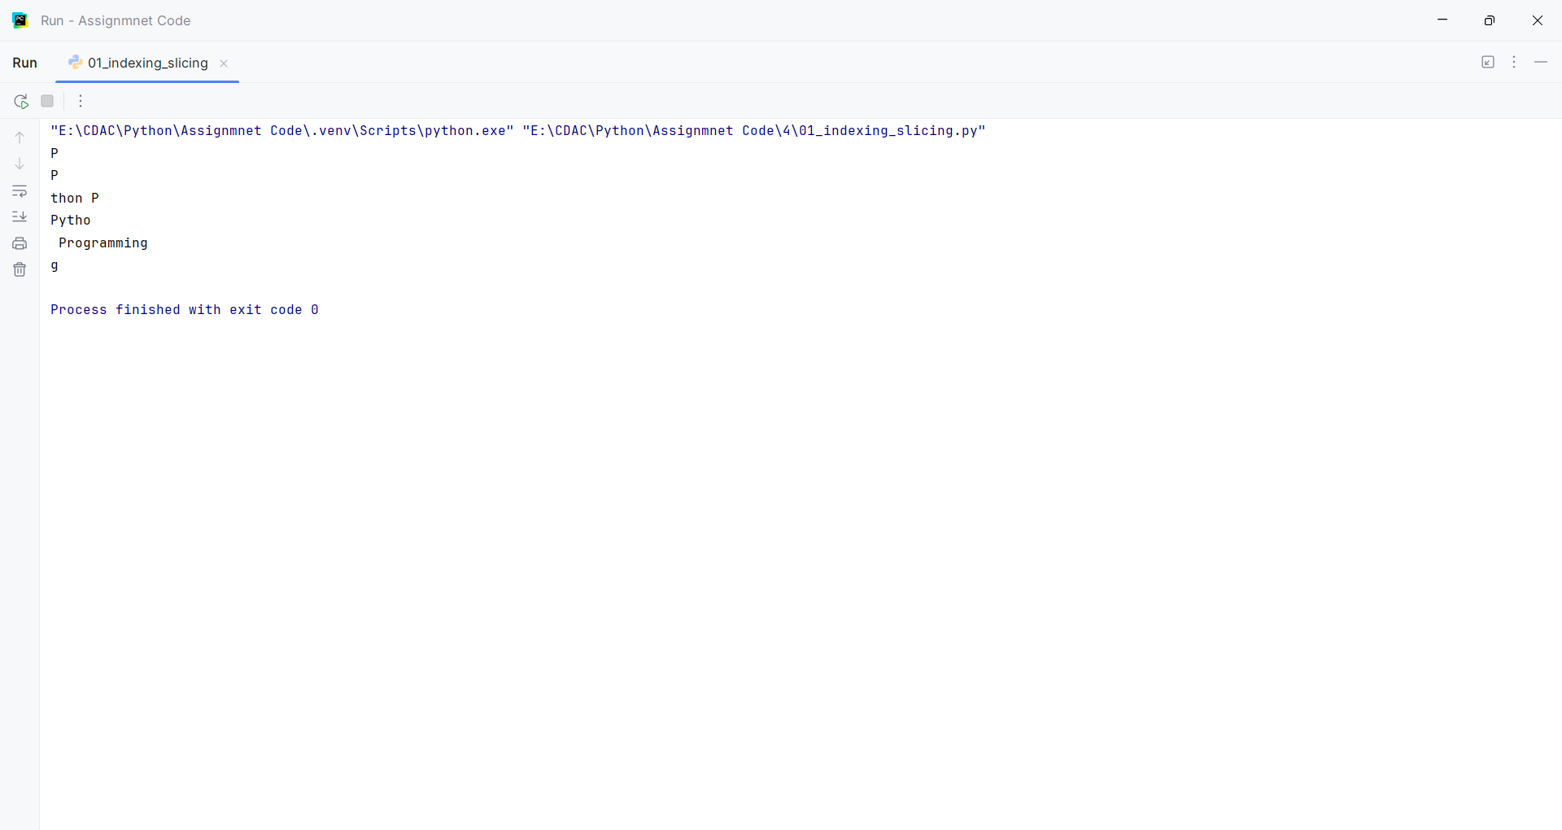

Question:
Given original_string = "Hello", demonstrate how to "update" this string to Goodbye by creating a new string and assigning it to the same variable.

Program
def update_string():
original_string = input("Enter a string: ")
original_string = "Goodbye"
print("Updated string:", original_string)
update_string()

Input and Output
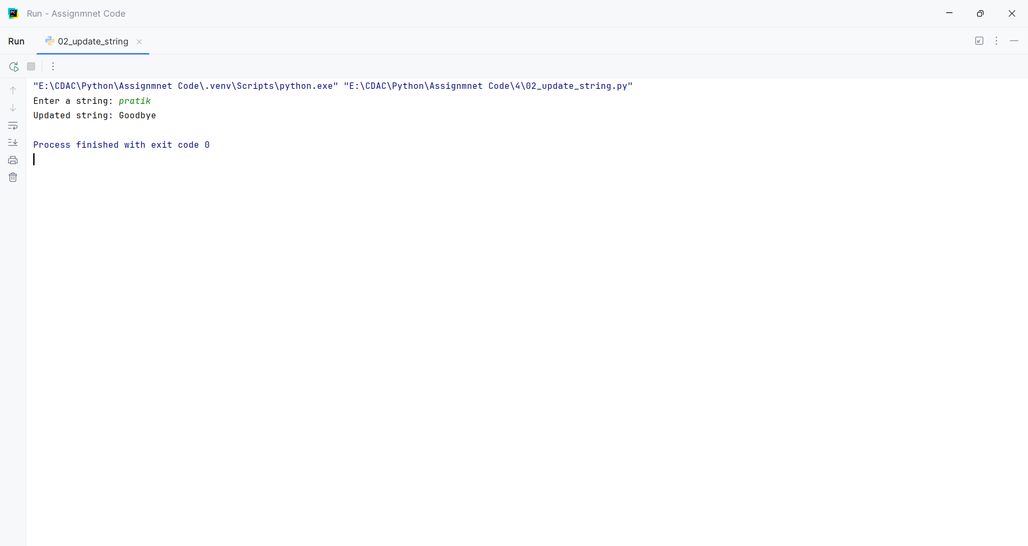

Question:
Write a string that includes a double quote within single quotes, and a single quote within double quotes, using escape characters where necessary.

Program
def show_quotes():
word = input("Enter a word: ")
string1 = 'He said \"' + word + '\"'
string2 = "It\'s a sunny day"
print(string1)
print(string2)
show_quotes()

Input and Output
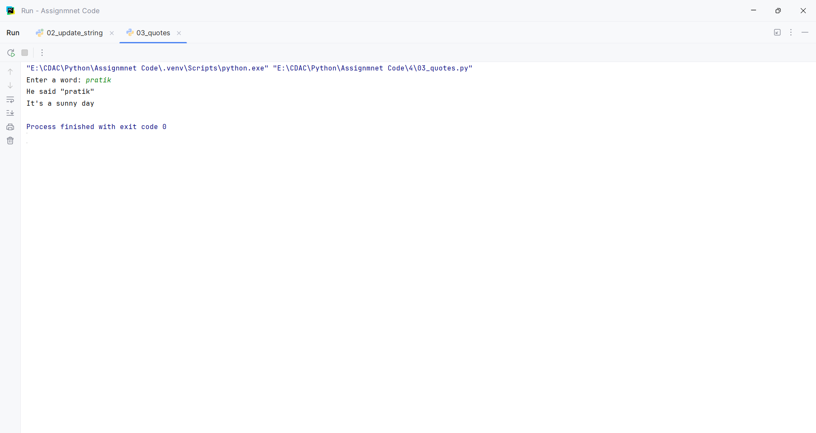

Question:
Demonstrate the use of the + operator for string concatenation.

Program
def concatenate():
first = input("Enter first string: ")
second = input("Enter second string: ")
result = first + " " + second
print(result)
concatenate()

Input and Output
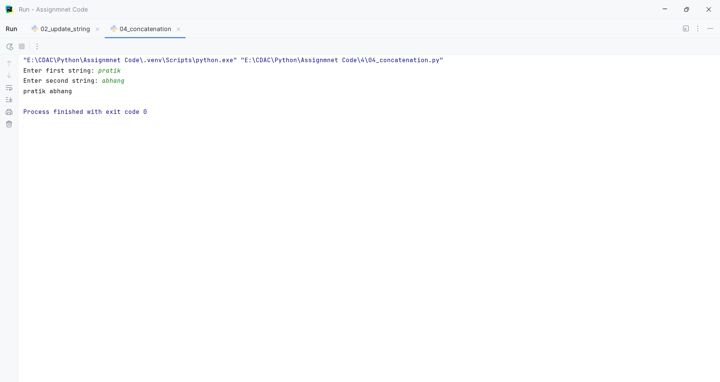

Question:
Demonstrate the use of the * operator for string repetition.

Program
def repeat_string():
word = input("Enter a word: ")
times = int(input("Enter number of times: "))
print(word * times)
repeat_string()

Input and Output
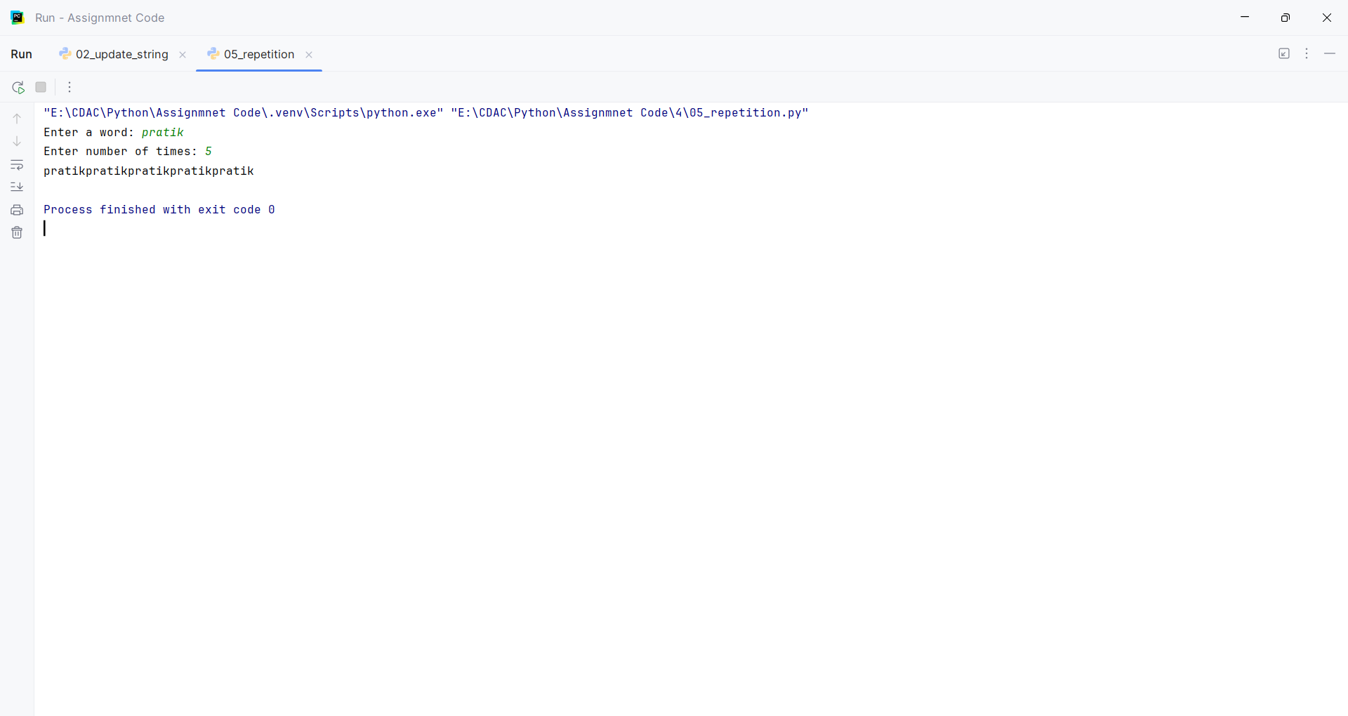

Question:
Use the in operator to check if a substring exists within a larger string.

Program
def check_substring():
text = input("Enter a string: ")
substring = input("Enter a substring: ")
print(substring in text)
check_substring()

Input and Output
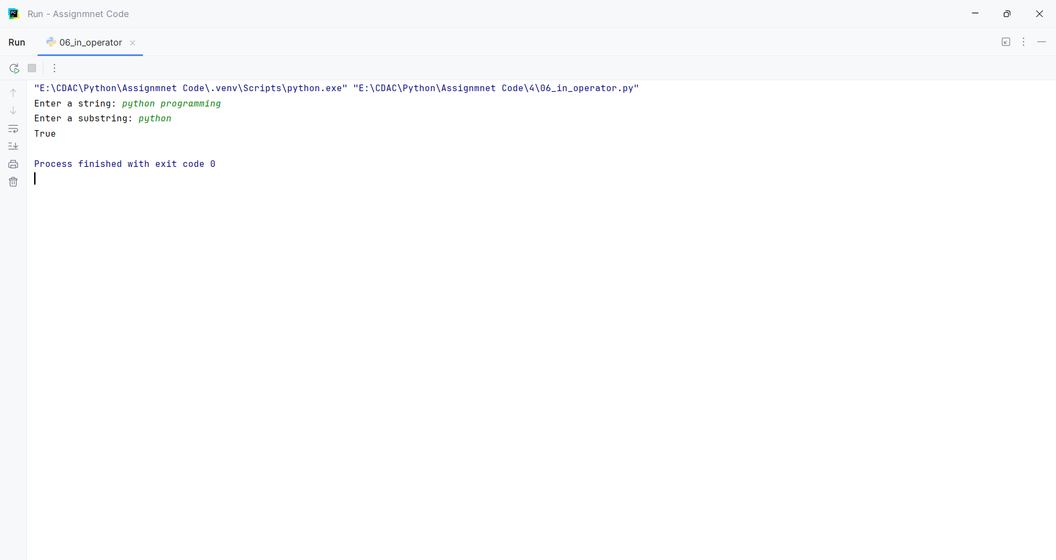

Question:
Use the not in operator to check if a substring does not exist within a larger string.

Program
def check_not_substring():
text = input("Enter a string: ")
substring = input("Enter a substring: ")
print(substring not in text)
check_not_substring()

Input and Output
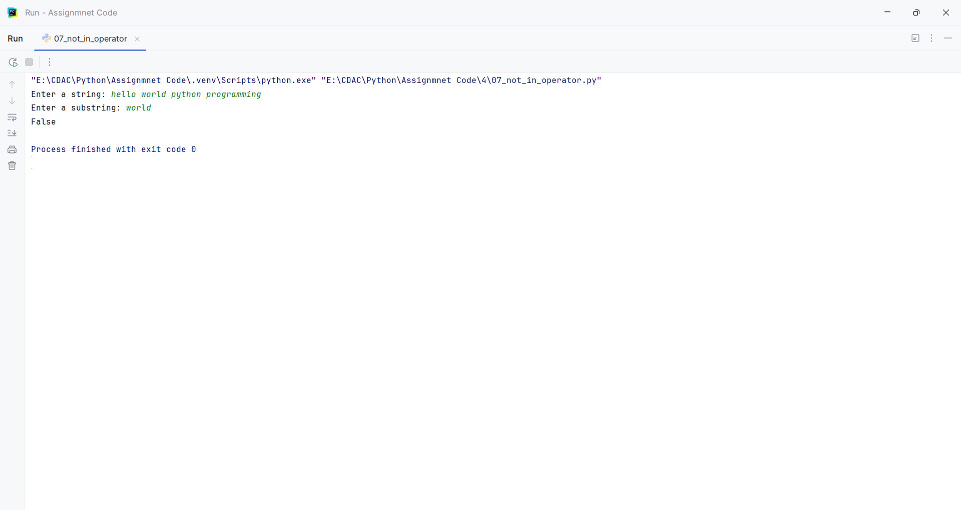

Question:
Given name = "Alice" and age = 30, use the f-string formatting method to create a string that reads: "Alice is 30 years old."

Program
def show_details():
name = input("Enter name: ")
age = int(input("Enter age: "))
print(f"{name} is {age} years old.")
show_details()

Input and Output
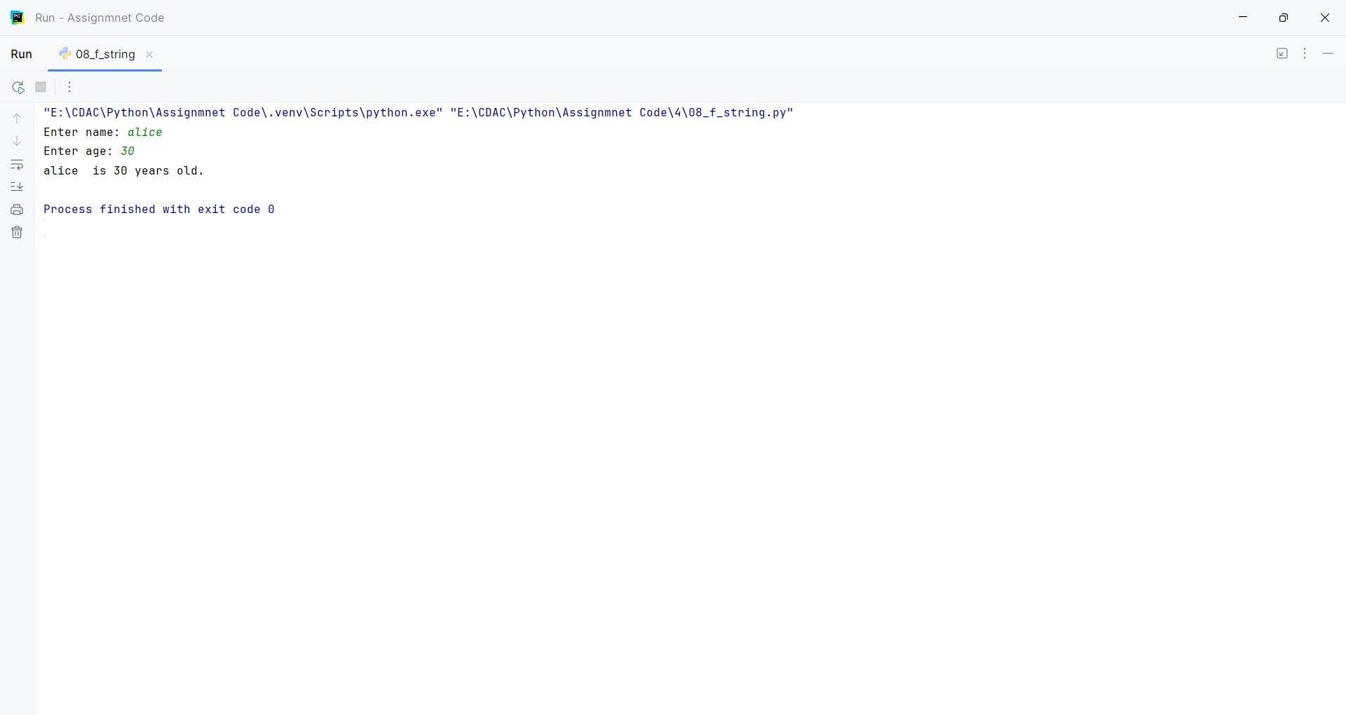.

Question:
Given text = " Python is FUN! ", use built-in string methods to:
• Convert the string to all lowercase.
• Convert the string to all uppercase.
• Remove leading and trailing whitespace.
• Replace "FUN" with "amazing".
• Check if the string starts with "Py".
• Check if the string ends with "!".
• Count the occurrences of the letter 'o'.

Program
def string_methods():
text = input("Enter text: ")
print("Lowercase:", text.lower())
print("Uppercase:", text.upper())
print("Without spaces:", text.strip())
print("Replace FUN:", text.replace("FUN", "amazing"))
print("Starts with Py:", text.strip().startswith("Py"))
print("Ends with !:", text.strip().endswith("!"))
print("Count of o:", text.count("o"))
string_methods()

Input and Output

